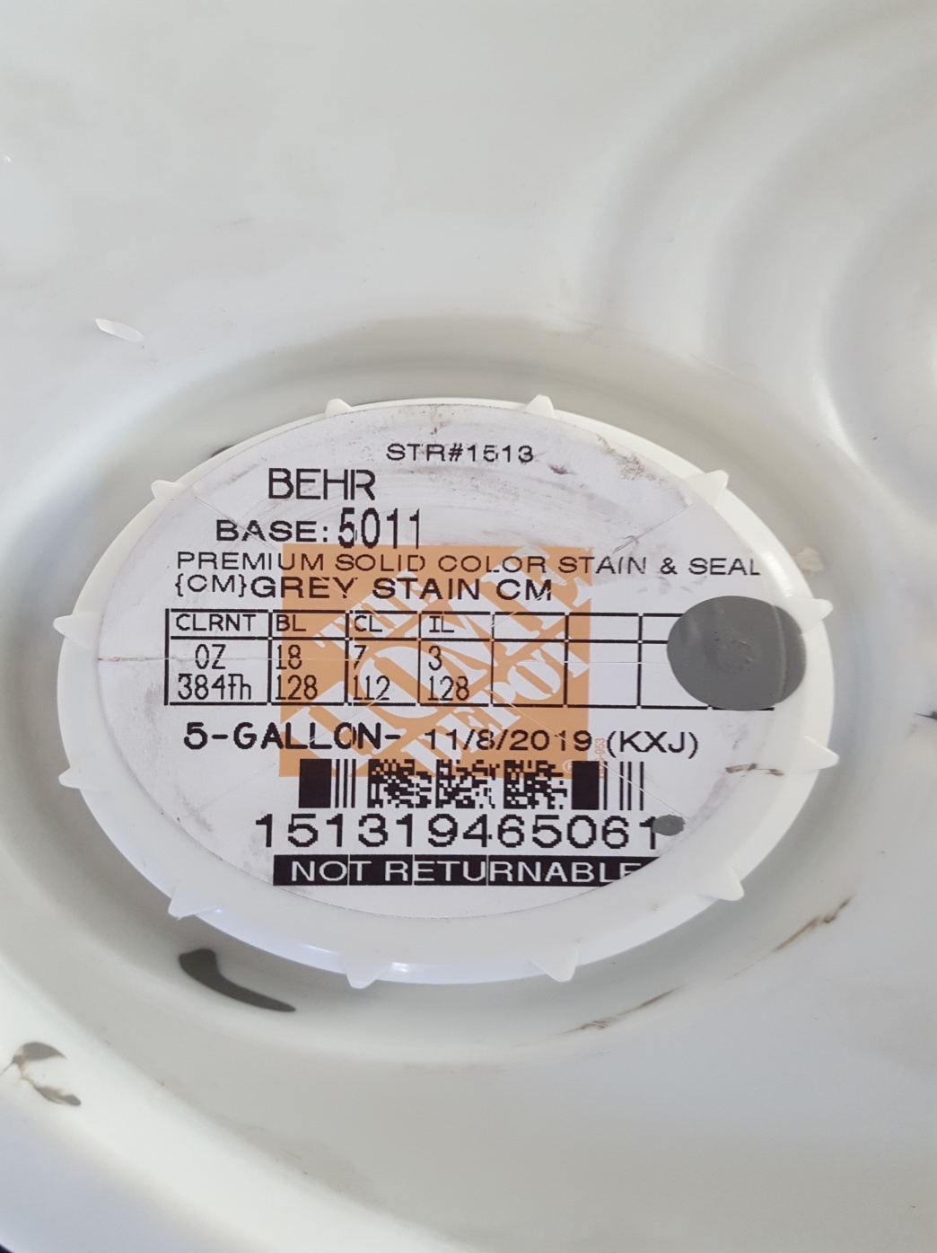

Guidance Regarding Grey Fence Color 7-31-2109

1. Several shades of grey and red earth are in use in CMHOA
2. Homeowners may continue the color currently in use for maintenance and repairs
3. New construction should consider this product from Home Depot—This is a heavy bodied stain—not transparent
4. New construction should consult with CMHOA-ACC committee, if they desire to explore approval for a different color BEFORE USING THE COLOR, PLEASE. Go to [www.countrymeadowshoa.org](http://www.countrymeadowshoa.org) for more information regarding construction approval.
5. For routine maintenance of existing/weathered grey fence, any semi-transparent grey stain may be used without a need for approval from CMHOA. HOA Board members appreciate notice of intent to perform exterior maintenance and/or repair with similar or same construction or color